**Ahmer Aziz Tasks:**

**Question 1:**

using System;

using System.Collections.Generic;

using System.Linq;

using System.Text;

using System.Threading.Tasks;

namespace Tasks

{

class Program

{

static void Main(string[] args)

{

Console.WriteLine("What is your name: ");

String userName = Console.ReadLine();

Console.WriteLine("Hello " + userName);

}

}

}

**Output:**

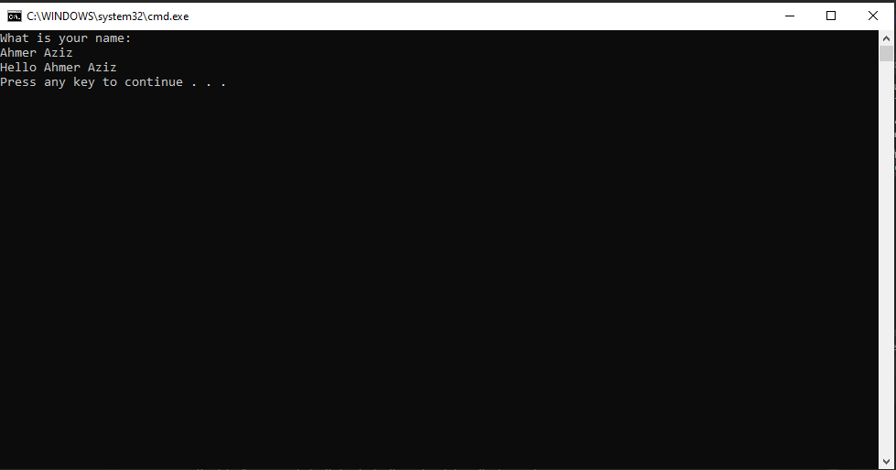

**Question 2:**

using System;

public class Class1

{

public Class1()

{

using System;

using System.Collections.Generic;

using System.Linq;

using System.Text;

using System.Threading.Tasks;

namespace Tasks

{

class Program

{

static void Main(string[] args)

{

int i;

Console.Write("Enter a Number : ");

i = int.Parse(Console.ReadLine());

if (i % 2 == 0)

{

Console.Write("Entered Number is an Even Number");

Console.Read();

}

else

{

Console.Write("Entered Number is an Odd Number");

Console.Read();

}

}

}

}

}

}

**Output:**

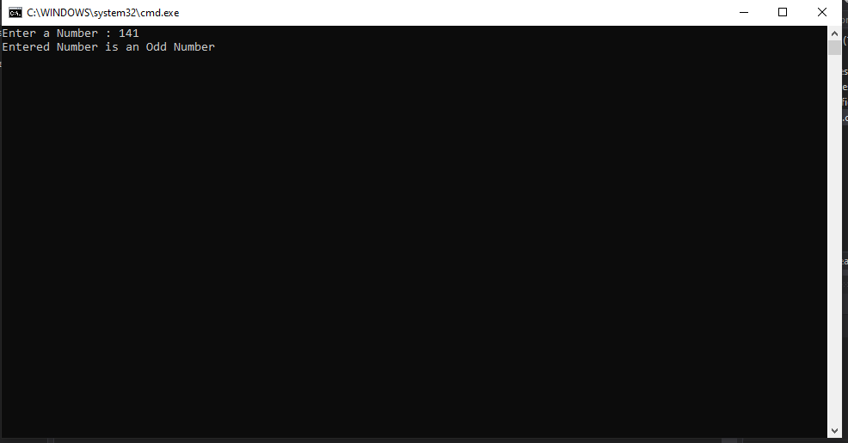

**Question 3:**

using System;

using System.Collections.Generic;

using System.Linq;

using System.Text;

using System.Threading.Tasks;

namespace Tasks

{

class Program

{

static void Main(string[] args)

{

Console.Write("Enter a Number 1: ");

int x = Convert.ToInt32(Console.ReadLine());

Console.Write("Enter a Number 2: ");

int y = Convert.ToInt32(Console.ReadLine());

int sum = x + y;

Console.WriteLine(sum);

}

}

}

**Output:**

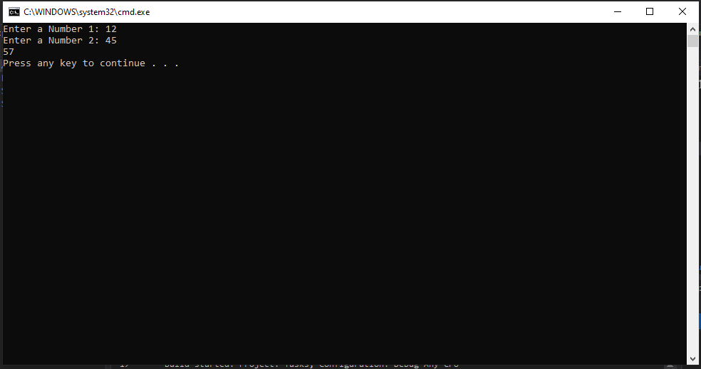

**Question 4:**

using System;

using System.Collections.Generic;

using System.Linq;

using System.Text;

using System.Threading.Tasks;

namespace Tasks

{

class Program

{

static void Main(string[] args)

{

int[] array = new int[5];

for (int i = 0; i < array.Length; i++)

{

Console.WriteLine("Enter a number:");

array[i] = Convert.ToInt32(Console.ReadLine());

for (int a = 0; a < 5; a++)

{

if (array[i] != array[a])

{

array[i] = int.Parse(Console.ReadLine());

Console.WriteLine("new\n");

}

}

array[i] = int.Parse(Console.ReadLine());

Console.WriteLine("exists\n");

}

Console.WriteLine(array);

Console.ReadKey();

}

}

}

**Question 5:**

using System;

using System.Collections.Generic;

using System.Linq;

using System.Text;

using System.Threading.Tasks;

namespace Tasks

{

class Program

{

static void Main(string[] args)

{

int[] arr = { 10, 324, 45, 90, 9808 };

int i;

int max = arr[0];

for (i = 1; i < arr.Length; i++)

if (arr[i] > max)

max = arr[i];

Console.WriteLine("Largest Number: " + max);

}

}

}

**Output:**

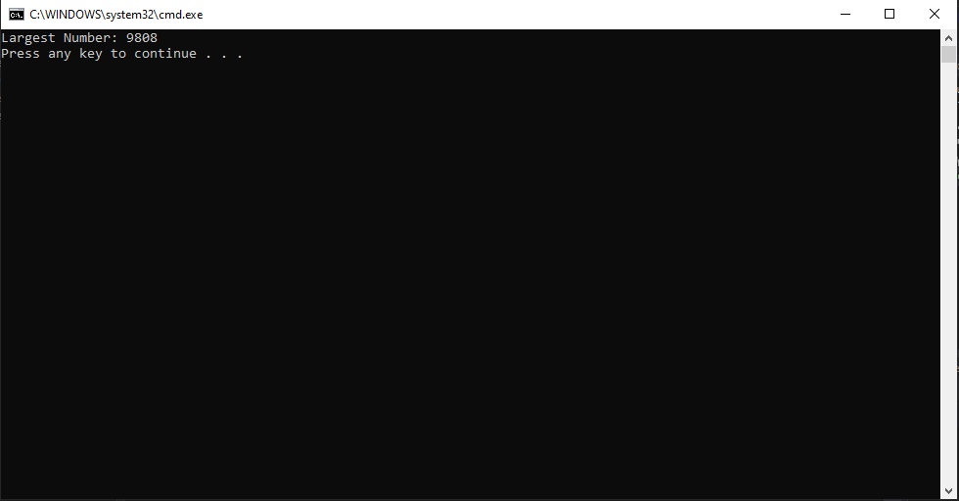

**Question 6:**

using System;

using System.Collections.Generic;

using System.Linq;

using System.Text;

using System.Threading.Tasks;

namespace Tasks

{

class Program

{

static void Main(string[] args)

{

int x;

int result;

Console.WriteLine("Enter a number:");

x = Convert.ToInt32(Console.ReadLine());

for (int i = 1; i <= 10; i++)

{

result = x * i;

Console.WriteLine("The table is : {0} x {1} = {2}", x, i, result);

}

}

}

}

**Output:**

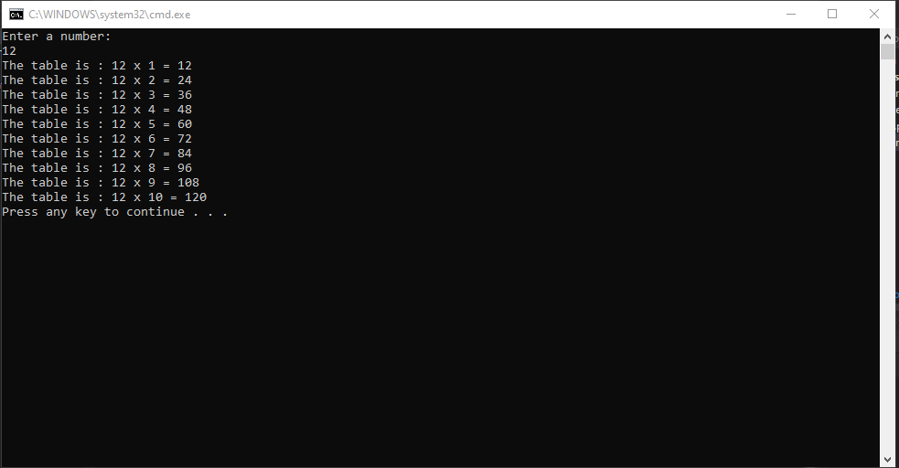

**Question 7:**

using System;

public class OddPosition

{

static void fun(int[] arr)

{

Console.WriteLine("Elements of given array present on odd position: ");

for (int i = 0; i < arr.Length; i = i + 2)

{

Console.WriteLine(arr[i]);

}

}

public static void Main()

{

int[] arr = new int[] { 15, 10, 12, 1, 2, 3, 4, 5 };

fun(arr);

}

}

**Output:**

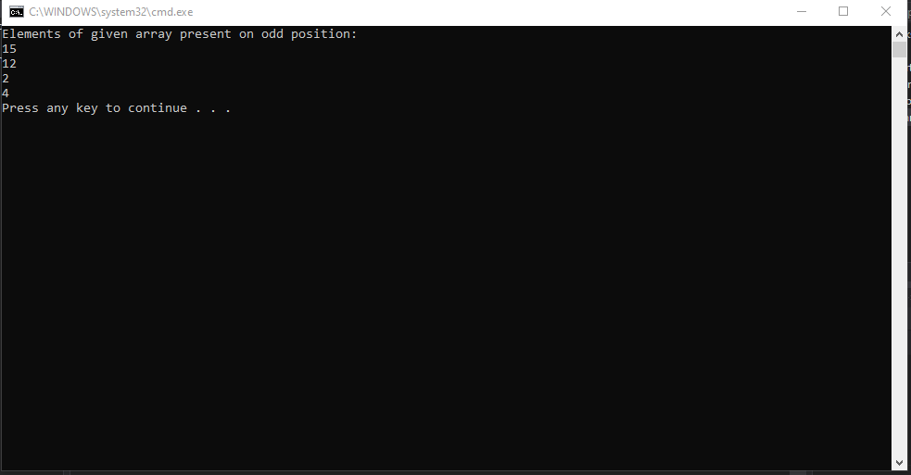

**Question 8:**

using System;

using System.Collections.Generic;

using System.Linq;

using System.Text;

using System.Threading.Tasks;

namespace Tasks

{

class Program

{

static bool isPrime(int n)

{

if (n <= 1)

return false;

for (int i = 2; i < Math.Sqrt(n); i++)

if (n % i == 0)

return false;

return true;

}

static void Main(string[] args)

{

if (isPrime(11))

Console.Write(" true");

else

Console.Write(" false");

}

}

}

**Output:**

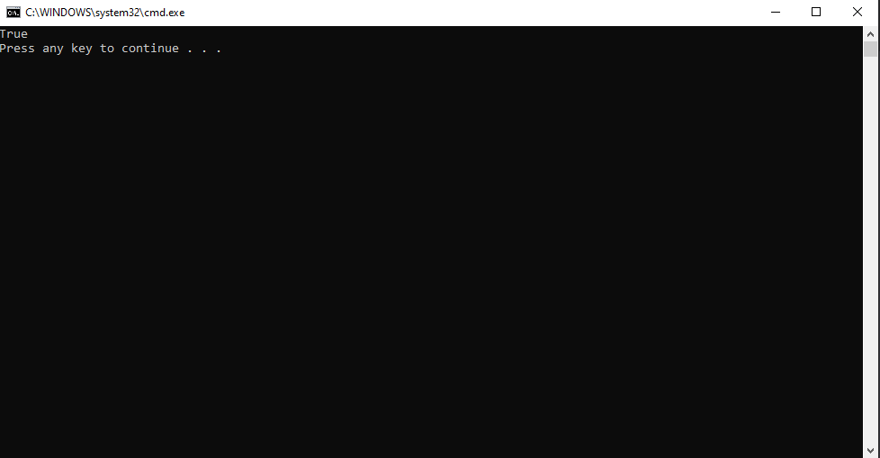

**Question 9:**

using System;

using System.Collections.Generic;

using System.Linq;

using System.Text;

using System.Threading.Tasks;

namespace Tasks

{

class Program

{

static void Main(string[] args)

{

int x, y;

for (x = 1; x <= 6; x++)

{

for (y = 1; y <= x; y++)

{

Console.Write("*");

}

Console.WriteLine();

}

Console.ReadLine();

}

}

}

**Output:**

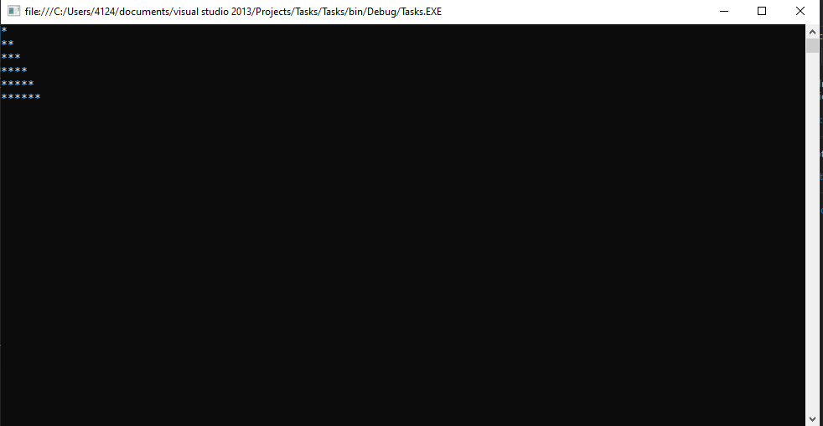

**Question 10:**

using System;

using System.Collections.Generic;

using System.Linq;

using System.Text;

using System.Threading.Tasks;

namespace Tasks

{

class Program

{

static void Main(string[] args)

{

int x, y;

for (x = 1; x <= 6; x++)

{

for (y = 1; y <= x; y++)

{

Console.Write(x);

}

Console.WriteLine();

}

Console.ReadLine();

}

}

}

**Output:**

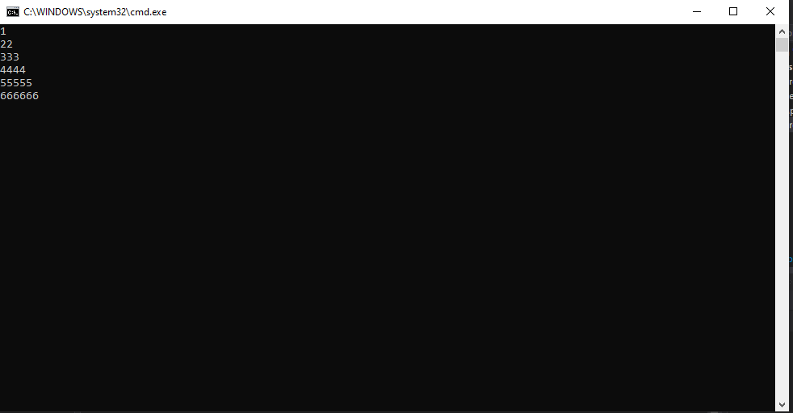

**Bonus Question:**

using System;

using System.Collections.Generic;

using System.Linq;

using System.Text;

using System.Threading.Tasks;

namespace Tasks

{

class Program

{

static void palindrome(int n)

{

int r, sum = 0, temp;

temp = n;

while (n > 0)

{

r = n % 10;

sum = (sum * 10) + r;

n = n / 10;

}

if (temp == sum)

Console.Write("Number is Palindrome.");

else

Console.Write("Number is not Palindrome");

}

static void Main(string[] args)

{

int n;

Console.Write("Enter the Number: ");

n = int.Parse(Console.ReadLine());

palindrome(n);

}

}

}

**Output:**

